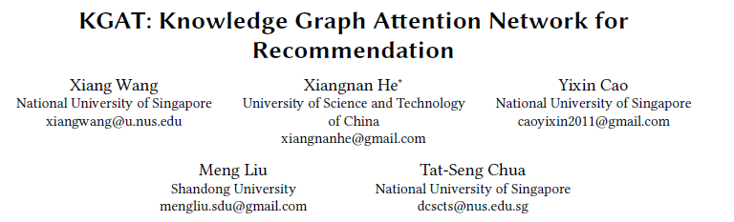

To provide more accurate, diverse, and explainable recommendation,it is compulsory to go beyond modeling user-item interactionsand take side information into account. Traditional methods like factorization machine (FM) cast it as a supervised learning problem, which assumes each interaction as an independent instance with side information encoded. Due to the overlook of the relations among instances or items (e.g., the director of a movie is also an actor of another movie), these methods are insufficient to distill the collaborative signal from the collective behaviors of users. (问题示例如下)

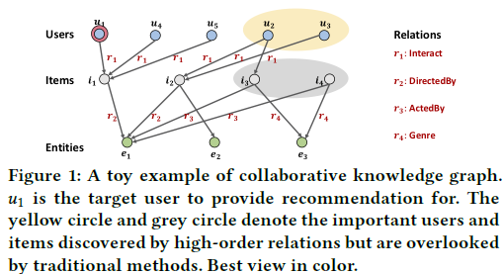

In this work, we investigate the utility of knowledge graph (KG), which breaks down the independent interaction assumption by linking items with their attributes. We argue that in such a hybrid structure of KG and user-item graph, high-order relations — which connect two items with one or multiple linked attributes — are an essential factor for successful recommendation. We propose a new method named

Knowledge Graph Attention Network (KGAT)

which explicitly models the high-order connectivities in KG in an end-to-end fashion. It recursively propagates the embeddings from a node’s neighbors (which can be users, items, or attributes) to refine the node’s embedding, and employs an attention mechanism to discriminate the importance of the neighbors.

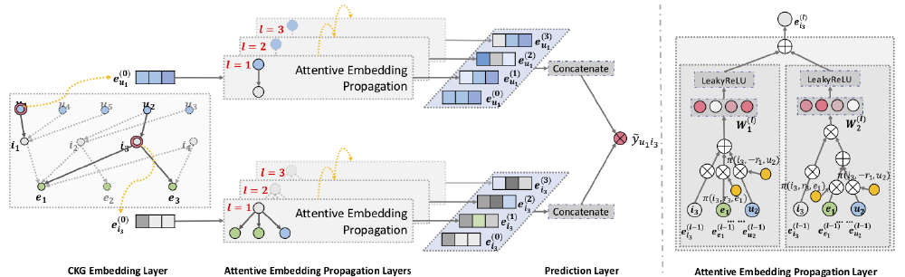

Figure 2: Illustration of the proposed KGAT model. The left subfigure shows model framework of KGAT, and the right subfigure presents the attentive embedding propagation layer of KGAT.

建模(待补充)，Information Aggregation 三种（attention）都用（GCN+GraphSage+Bi-Interaction）

关键创新点，针对上文问题，提出 High-order Propagation 推测实体间潜在关联：



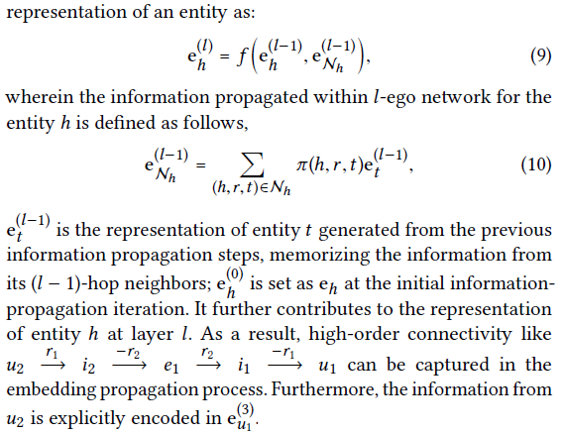

Our KGAT is conceptually advantageous to existing KG-based recommendation methods, which either exploit highorder relations by extracting paths or implicitly modeling them with regularization. Empirical results on three public benchmarks show that KGAT significantly outperforms state-of-the-art methods like Neural FM [11] and RippleNet [29]. Further studies verify the efficacy of embedding propagation for high-order relation modeling and the interpretability benefits brought by the attention mechanism. We release the codes and datasets at <https://github.com/xiangwang1223/knowledge_graph_attention_network>